HBM4EU TASK 7.5 TEMPLATE
CHEMICALS FACT SHEET FOR CHILDREN PARTICIPANTS (6-11 YEARS)

INSTRUCTIONS ON HOW TO USE THIS TEMPLATE
This document is a template, which can be used to develop an fact sheet on chemicals for children participants in HBM4EU surveys (ages 6-11 years old). You may introduce changes, as required by the study design and national requirements. To use this template, adjust the text as you find appropriate for your study.
The HBM4EU templates for children are:
“CH _IL – Information leaflet”: Information Leaflet for Children Participants (6-11 years).
“CH_QA – Questions and Answers”: Questions and Answers for Children Participants (6-11 years).
“CH_AF – Assent form”: Assent form for Children Participants (6-11 years).
“CH_FS – Fact Sheet”: Fact sheet on chemicals for Children Participants (6-11 years).
“ADOL-CH_CIC - Consent Form Parent or Legal Guardian”: “Adjusted Consent Form for Parents / Legal Guardians of Young Participants”.

Encoding of task 7.5 templates
The templates prepared by task 7.5 are given an acronym, shown in the footer, which denotes the type, version, year of last revision and follows the key:
TYPE: IL = Info Leaflet, CIC = Certificate of Informed Consent, RCY = Reply card (Yes), RCN = Replay card (No), WF = Withdrawal form, PRL = Personal results letter, AF = Assent form
TARGER AUDIENCE: AD = Adults, CH = Child, ADOL = Adolescents
VERSION: Vxx = Version No.
DATE OF LAST REVISION: DD-MM-YY

Do you want to learn more about the chemicals HBM4EU
scientists will study?
You can, by reading this leaflet!
[You may want to give some very simple information about the chemicals, which will be investigated]
The HBM4EU scientists want to study chemicals called ‘[XXX]’. Do you know what they are? I don’t!
I don’t either! Let’s read on to learn!
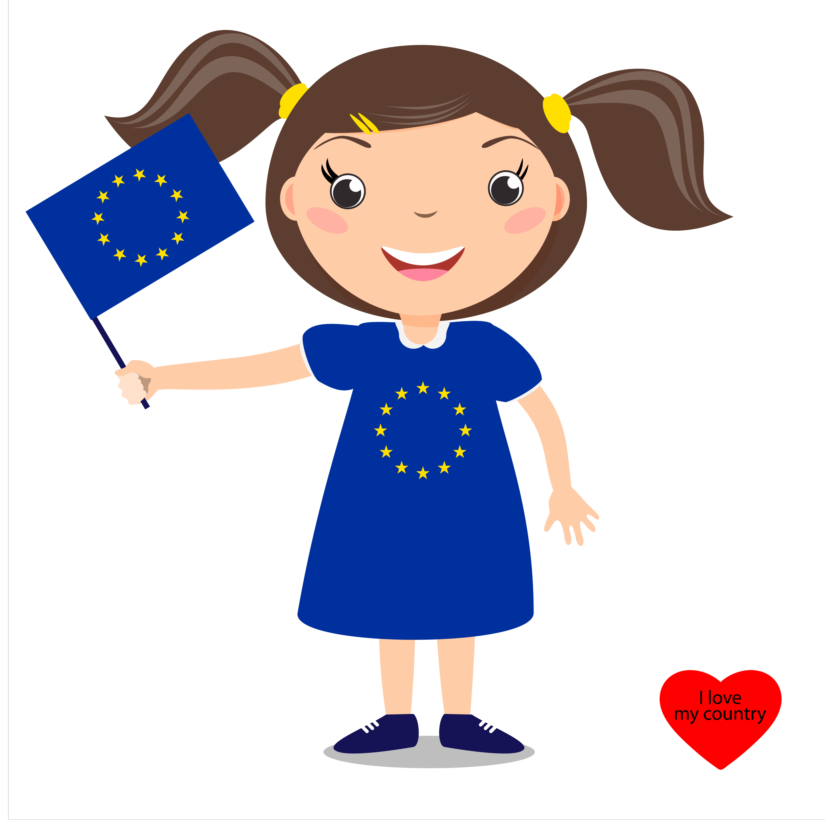

Where can XXX [the chemical under investigation] be found?
[Use pictures to describe possible sources of exposure to the chemicals under investigation].

What problems can XXX [the chemical under investigation] it cause?
[Use pictures to describe possible health effect to the chemicals under investigation. If possible, give some advice to control exposure].

How can we keep it away from us?
[If possible, give some advice to control exposure].

